**LIFE-CYCLE PROCESSES: PART TWO**

**SERVICE TRANSITION: PHASE AND PRPCESS OVERVIEW**

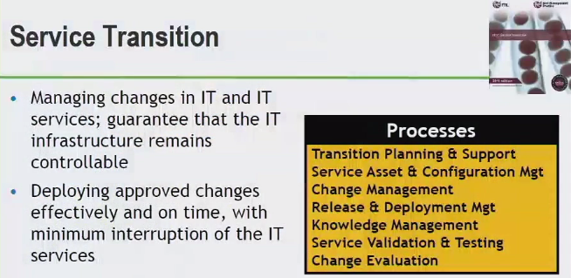

ST

TPS – TRANSITION PLANNING & SUPPORT

SACM – SERVICE ASSET CONFIG. MAN.

CHANGE MAN.

RELEASE & DEPLOY MGT.

KNOWLEDGE MAN.

**TRANSITION PLANNING AND SUPPORT**

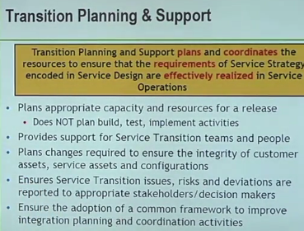

* PROVIDE THE OVERALL PLANNING AND SUPPORT FOR THE ST PHASE ITSELF
* COORD. ACTIVITES – PROJECTS/RESOURCES/SUPPLIERS – ALL PIECES FROM DESIGN TO OPS.

COORDINATING PROCESSS ACROSS THE PHASE

**SERVICE ASSET AND CONFIGURATION MANAGEMENT**

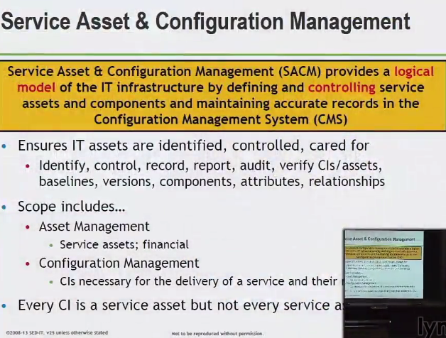

CI

SERVICE ASSET AND CONFIG.

**EXAMPLE**

SERVERS

NETWORK COMPONENTS

DATABASES

= ASSETS (FINANCIAL ASSETS)

**ATTRIBUTE**

LICENSE PLATE DATE – WHAT DO WE NEED TO KNOW ABOUT THAT

SERIAL #, PURCHASE DATE, INSTALL DATE

RELATIONSHIP WITH ASSETS OR CI’S (CONFIGURATION ITEMS)

**CONFIG. MAN.**

DATA IN ASSESSING CHANGES, AND PLANNING RELEASES

TECHNOLOGY REFRESHES

AUDIT INFORMATION

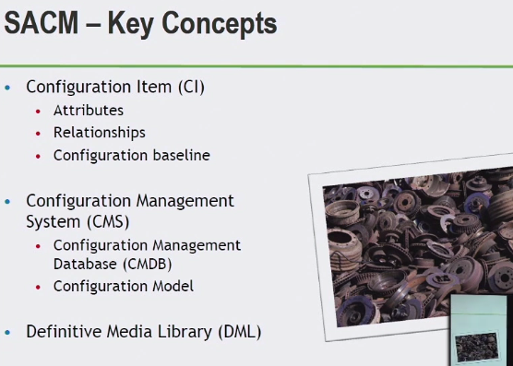

**THE FOUR PHASES OF RELEASE AND DEPLOYMENT MANAGEMENT**

**CHM**

CHANGE SAYS NOW YOU HAVE THE AUTHORITY TO GO INTO RELEASE AND DEPLOYMENT ***PLANNING***

* WHEN FINISHED WE GET AUTHORIZATION FROM CHM TO CREATE THE RELEASE
* CHANGE IS CONTROLLING HOW WE WALK THROUGH – APPROPRIATE APPROVAL
* MAKE SURE WE HAVE

**PLANNING**

* TEST PLANS UNDERSTOOD
* PASS/FAIL CRITERIA MOVING THROUGH 4 PHASES
* PLANNING/LOGISTICS FINANCIALS

AFTER…

GET THE AUTHORIZATION FROM Chm TO MOVE INTO **RELEASE BUILD AND TEST**

**BUILD & TEST**

* ENDS W/ CHANGE AUTHORIZATION
* PUT INTO DML – BUILD TESTED AND STORED (DIGITAL MEDIA LIBRARY)

**DML**

* STAGING PIECE GOES INTO DEPLOYMENT

**DEPLOYMENT**

* RELEASE PACKAGE/UNITS

**REVIEW & CLOSE**

* SERVICE TRANSTION
* FORMAL REVIEW – COMPLETED DOCUMENTATION, INFO TRANSFER

4 **PHASES:**

PLAN IT

BUILD TEST

DEPLOY IT

REVIEW & CLOSE

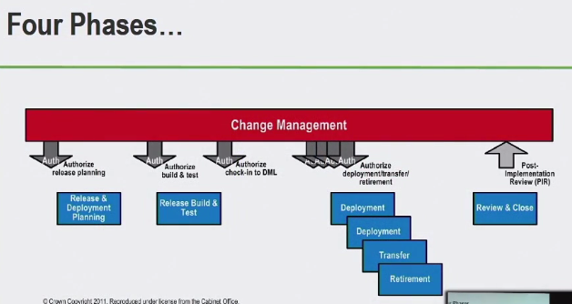

RELATIONSHIP W/ CHANGE MANAGEMENT (ChM) and ACTIVITES PHASES OF RELEASE AND DEPLOYMENT

**KNOWLEDGE MANAGEMENT**

SYSTEM THAT HELPED US TO SEARCH, CLASSIFY, AND ORGANIZE – QUICKLY RECALL INFO TO SUPPORT CUSTOMERS

Right INFORMATION RIGHT PLACE AND PERSON AT THE RIGHT TIME TO MAKE INFORMED DECISIONS

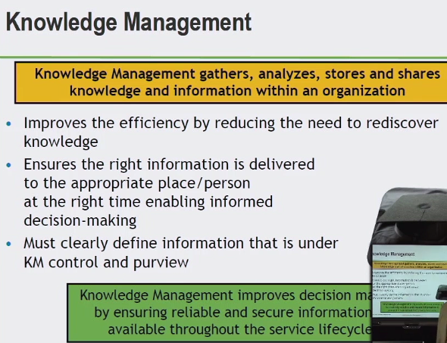

* HAVE THE RIGHT INFORMATION
* AVOID LEARNING THE SAMETHING OVER AND OVER

MUST CLEARLY DEFINE INFORMATION THAT IS UNDER KM control and PURVIEW

**DATA, INFORMATION, KNOWLEDGE, WISDOM STRUCTURE**

KNOWLEDGE MANAGEMENT STRUCTURE – DIKW – DATA INFORMATION KNOWLEDGE WISDOM

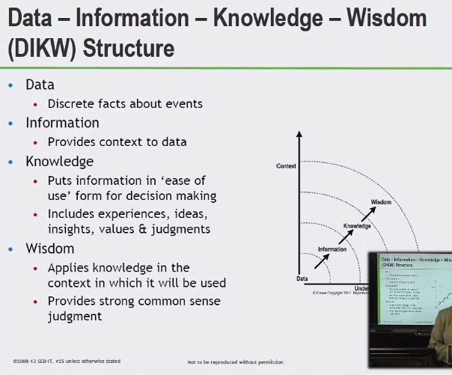

**SERVICE KNOWLEDGE MANAGEMENT SYSTEM**

**(SKMS)**

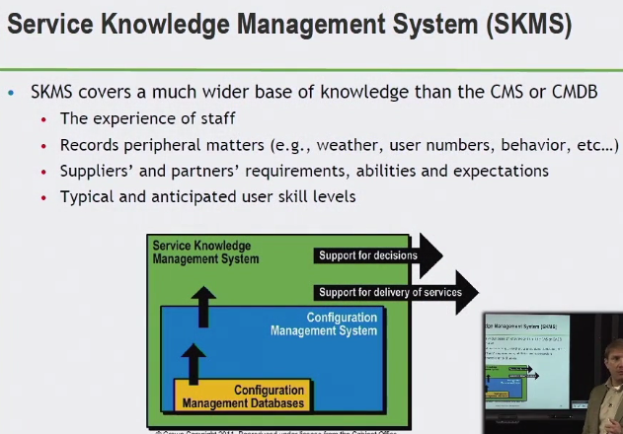

SUPPLIER CONTRACT MANAGEMENT INFORMATION SYSTEM

CAPACITY MANAGEMENT INFORMATION SYSTEM

DML – DEFINITIVE MEDIA LIBRARY

PORTFOLIO

SKMS – CENTRAL POINT OF KNOWLEDGE

CORE PIECE OF KNOWLEDGE MANAGEMENT

* ENSURE DON’T WANT TO REDISCOVER INFO OVER AND OVER
* TOOL/SET OF TOOLS/DATABASES TO GET THE INFO WHEN WE NEED IT

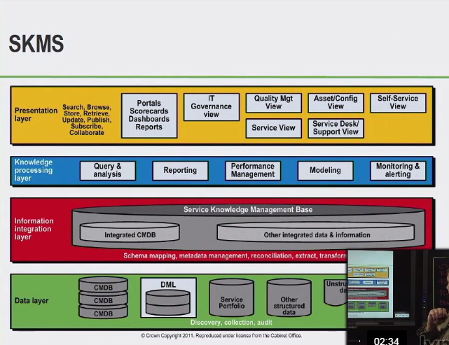

DATA – INFORMATION – KNOWLEDGE – WISDOM (PRESENTATION LAYER) ---- DIKW

**SERVICE Operation: PHASE AND PROCESS OVERVIEW**

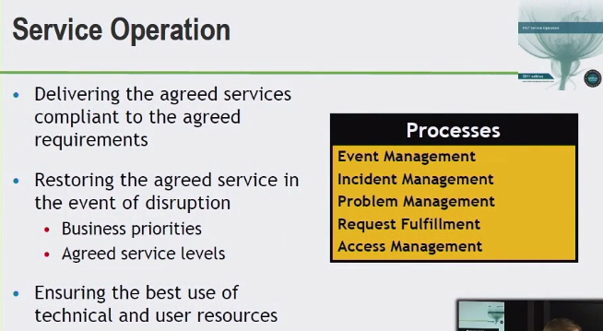

**SO**

* EVENT MAN.
* INCIDENT MAN.
* PROBLEM MAN.
* REQUEST FULFILLMENT
* ACCESS MAN.

**EVENT MANAGEMENT**

ENTRY POINT OF **SO**

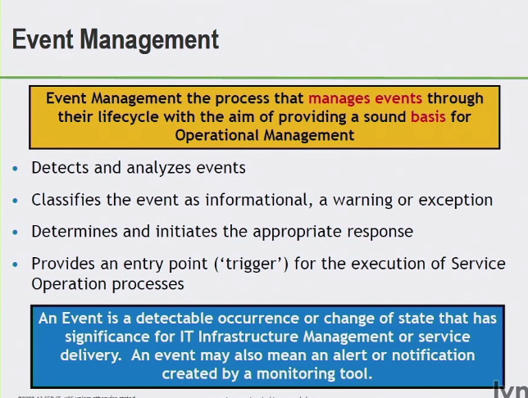

* **MONITORING/HAVING MONITING TOOLS IN PLACE TO WATCH CRITICAL CI’S (CONFIG. ITEMS)**
* MORE MONITORING, THE BETTER, MUST HAVE RESOURCES, GOOD UNDERSTANDING OF RESPONSIBILITIES AND ACCOUNTABILITIES PERSPECTIVE
* WHO, WHAT ACTIONS ARE TAKEN SEEN OUT OF THESE MONITORING TOOLS
* CATCH THEM BEFORE THEY BECOME INCIDENTS OR CAUSE DAMAGE TO CUSTOMERS
* DETERMINE AN APPROPIRATE/AUTOMATED RESPONSE

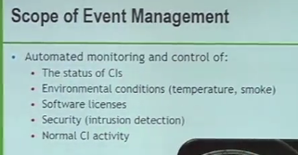

**CI –** REQUIRED FOR A SUCCESSFUL DELIVERY OF A SERVICE (NETWORKS, ROUTERS, OS’S EXAMPLE)

**NORMAL CI ACTIVITY**

SOMEBODY LOGS IN – EVENT (KEPT AS A LOG)

EMAIL IS SENT

“CHECK THE LOGS”

**ACTIVE AND PASSIVE MONITORING TOOLS**

ACTIVE - WATCHING – PINGING CI’S – INFO GATHERED – SETS UP ALERTS

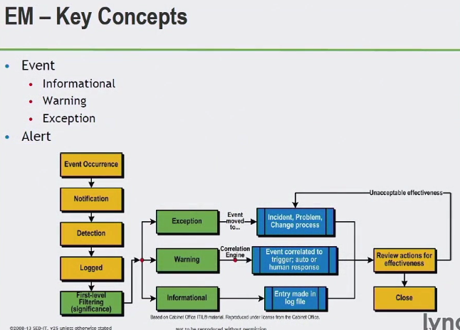

**EVENTS (MONITORING TOOLS)**

INFORMATIONAL

* GENERATES A LOG ENTRY
* TRACK NORMAL CI ACTIVITY

WARNING

* WITHIN A RANGE TO TAKE ACTION
* EXAMPLE: MEMORY USAGE
* ‘THOUGHT I’D LET YOU KNOW’
* AUTO OR HUMAN RESPONSE

EXCEPTION (THRESHHOLD TO *INCIDENT MANAGEMENT)*

* BREACHED SOME THRESHOLD DETERMINED – SLA – IT ORG. THAT ACTION HAS TO BE TAKEN
* INCIDENT TICKET OR PROBLEM TICKET

CAN EVENT MONITORING TOOLS – CAN BE CI’S

EVENT MONITORING TOOL MONITORING AN IMPORTANT CI AND MONITORING TOOL GOES DOWN – INCIDENT

**INCIDENT MANAGEMENT**

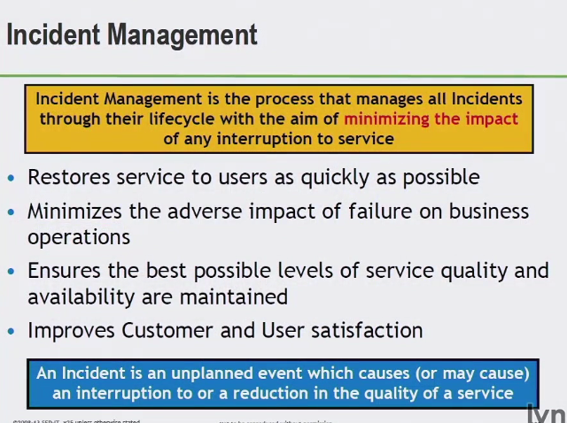

**SERVICE DESK (SD) –** FIND OUT ABOUT INCIDENTS VIA EVENT MONITORING TOOLS

* **CUSTOMERS/TECH. STAFF** CAN CALL SERVICE DESK FOR INCIDENTS
* INCIDENT TICKET IS CREATED
* OWNS LIFE CYCLE OF TICKET – OPEN & CLOSE

**THIRD-PARTIES**

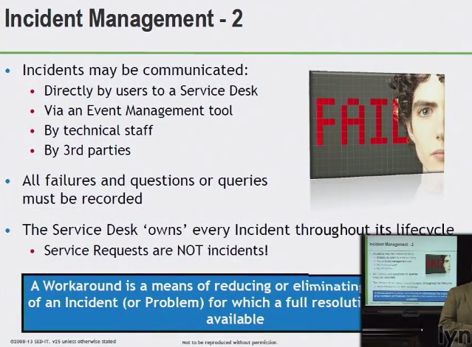

A **WORKAROUND** IS A MEANS OF REDUCING OR ELMINIATING THE IMPACT OF AN INCIDENT (OR PROBLEM) FOR WHICH ALL RESOLUTION IS NOT YET AVAILABLE.

WORKAROUND

* KNOWN ERROR
* EVERYTHING MUST BE RECORDED SD OWNS TICKET THROUGHT IT’S LIFE CYCLE

**KEY CONCEPT OF INCIDENT MANAGEMENT**

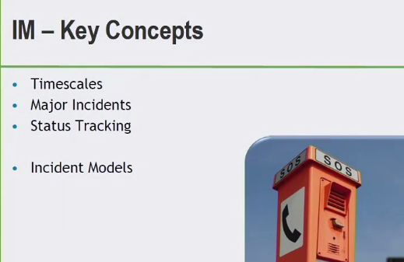

**TIMESCALES**

* ALIGN WITH SERVICE LEVEL AGREEMENTS (SLA’S)
* OLA’S
* UNDERPINNING CONTRACTS – RESTORE SERVICES QUICKLY
* FOR DIFFERENT STEPS/PROCEDURES
* HOW LONG FOR ESCALATION TO TAKE PLACE
* PRIORTIZAITON SCHEMA
* URGENCY/IMPACT – HELPS DETERMINE PRIORITY – PRIORITY TABLE

**MAJOR INCIDENTS**

* AT IT’S VERY HIGHEST PRIORITY LEVEL
* USUALLY NOT ONE CALL BUT 50 CALLS – “ONE BIG CALL”
* HANDLE THESE DIFFERENT THAN SIMPLE INCIDENTS
* DEPARTMENT/ORG. WIDE
* MUST QUICKLY ATTACK AND RESTORE SERVICE
* SEPARTE PROCESS AND MODEL TO TRACK THESE

**STATUS TRACKING**

* OPEN STATUS
* IN PROGRESS
* RESOLVED
* CLOSED

**INCIDENT MODELS**

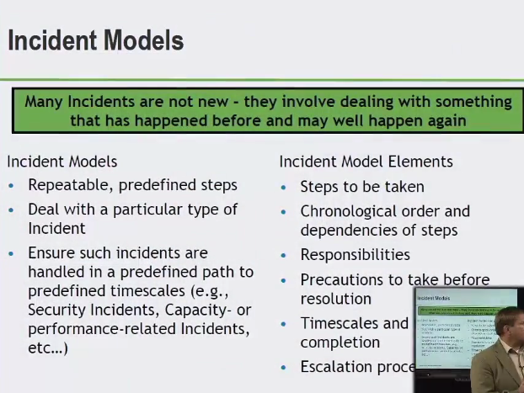

(RESPONSIBILITIES) RACI CHART – RESPONSIBLE ACCOUNTABLE CONSULTED AND INFORMED

**ACTIVITES OF INCIDENT MANAGEMENT**

SERVICE DESK OWNS EVERY INCIDENT THROUGH IT’S LIFECYCLE – ESCALATIONS THAT MAY HAVE TO TAKE PLACE

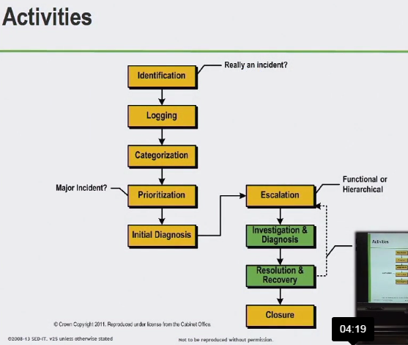

**IDENTIFY**

**LOGGED**

* DATE/TIME STAMP

**CATEGORIZATION**

* HEIARCHY OR SCHEMA
* DIFFERENT SELECTION OF DROP DOWN BOXES
* NOT A GOOD IDEA TO HAVE MULTIPLE SUB-LEVELS AND SUB CATEGORIES – GRANULARILY – HARD TO MANAGE

**PRIORTIZATION**

* P1 P2 P3
* SEV 1 SEV2 SEV3
* URGENCY/IMPACT – DETERMINE GENERAL PRIORITIES

**INITIAL DIAGNOSIS**

* KNOWN ERROR THAT EXISTS?
* RESOLVE INCIDENT AT LOWEST LEVEL AS POSSIBLE
* TIER 1 – LEVEL 1

**ESCALATION**

* FUNCTIONAL ESCALATION

TO SERVICE DESK TECH./APP./IT OPS MANS

* HEIARCHICAL ESCALATION

GOES TO MORE MANAGERIAL BACKING FROM HEIARCHY STANDING

**INVESTIGATION & DIAGNOSIS**

**RESOLUTION & RECOVERY**

* IDENTIFY AND POSSIBLY APPLY AND TEST IT
* COMPLETE USER CALL WITH SERVICE DESK – POSITIVE CONFIRMATION THAT INCIDENT IS RESOLVED
* MIGHT HAVE TO REESCALATE MANY TIMES TO RESOLVE THE INCIDENT
* COORDINATION

**CLOSURE**

* CLOSURE CATEGORIZATION
* USER SATISFACTION SURVEY
* DOCUMENTATION TESTS
* FORMAL CLOSURE
* MARK INCIDENT IN CLOSED STATUS

**INCIDENT-MANAGEMENT INFERFACES**

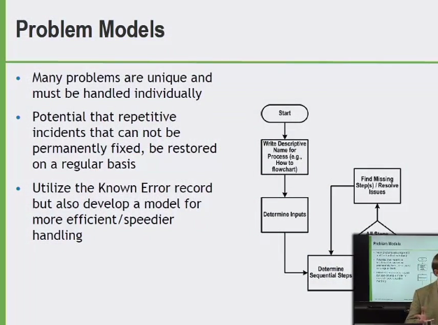

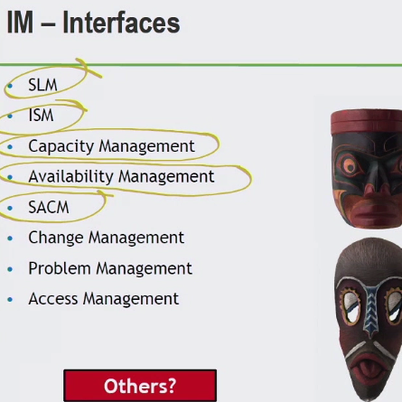

**SERVICE LEVEL MANAGEMENT**

* HELPS DRIVE CERTAIN TIMESCALES ESCALATIONS HOW WE HANDLE INCIDENTS

**INFORMATION SECURITY MANAGEMENT**

* DETECT SECURITY RELATED INCIDENTS ASAP
* MIGHT ESCALATE TO SECURITY MANAGEMENT GROUP

**CAPACAITY MANAGEMENT**

* CAPACITY RELATED ISSUES/INCIDENTS BASED ON PERFORMANCE

**AVAILABILITY MANAGEMENT**

* TICKETS CREATED - TRENDING - IMPACTS TO AVAILABILITY DUE TO DOWNTIME

**SACM SERVICE ASSET CONFIGURATION MANAGEMENT**

* CI’S – AFFECTED
* GET A VIEW OF CONFIG. MAN. SYS
* UNDERSTAND/IDENTIFY CI’S

**CHANGE MANAGEMENT**

* RESULT OF MAJOR INCIDENT CAN RESULT IN AN EMERGENCY CHANGE
* MAKE SURE APPROVED BY CHANGE MANAGEMENT – BREAK FIX ACTIVITIES

**PROBLEM MANAGEMENT**

* TRENDING OR REOCCURING INCIDENTS MIGHT BE INPUT INTO A PROBLEM TICKET TO REDUCE NUMBER OF INCIDENTS
* POLICY – EVERY MAJOR INCIDENT PROBLEM TICKET ROOT CAUSE ON WHY MAJOR INCIDENT TOOK PLACE

**ACCESS MANAGEMENT**

* GRANTING AUTHORIZED USERS TO HAVE ACCESS TO SERVICES
* TRACKING VIOLATIONS TO ACCESS

THINGS TO REMEMBER:

INCIDENT MANAGEMENT – RESTORE SERVICE AS QUICKLY AS POSSIBLE USE KNOWLEDGE TOOLS TO TRY TO RESOLVE THAT AT LOWEST LEVEL POSSIBLE

**PROBLEM MANAGEMENT**

INCIDENT – OCCURS POTENTIAL PROBLEM THERE

REDUCE # OF REOCCURING INCIDENTS BY FINDING ROOT CAUSE – KNOWN ERRORS, WORKAROUNDS, and SOLUTIONS

POTENTIALLY REDUCE PAIN THOSE INCDENTS THAT CAN’T BE AVOIDED

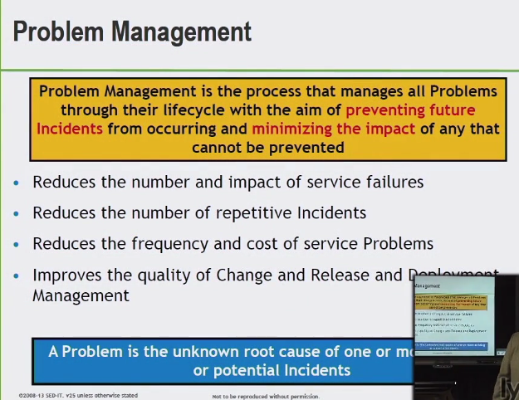

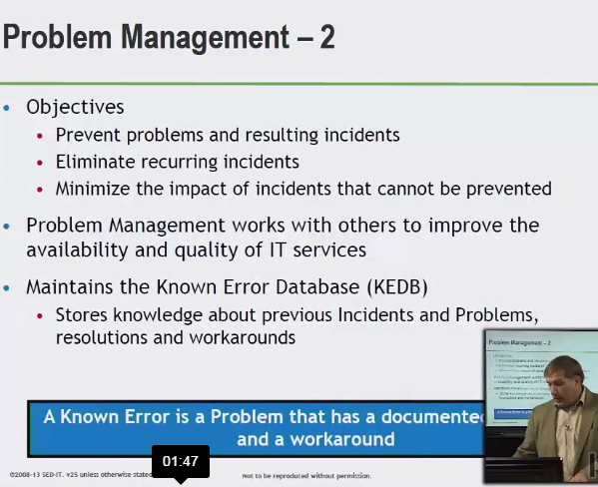

1. **PROBLEM** – UKNOWN ERROR
2. **ROOT CAUSE ANALYSIS (RCA)** – WHAT THE ROOT CAUSE(S) ARE?
3. **KNOWN ERROR (NAME TO ERROR) – KNOWN ERROR DATABASE (KEDB) – KNOWLEDGE ABOUT INCIDENTS**
4. **SOLUTION**
5. **CHANGE AND RELEASE**

**KEY CONCEPT OF PROBLEM MANAGEMENT**

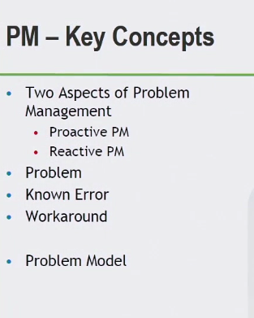

**PROACTIVE**

* HOW DO WE REMOVE PROBABILITY/POSSIBILITY OF more PROBLEMS IN THE FUTURE

**REACTIVE**

* REACTING TO INCIDENTS, MAJOR INCIDENTS – OPEN TICKET - RESEARCH

**PROBLEM-MANAGEMENT ACTIVITIES**

MAKE SURE CATEGORIZATION SCHEMAS MATCH UP

INCIDENTS AND PROBLEMS

CLOSURE

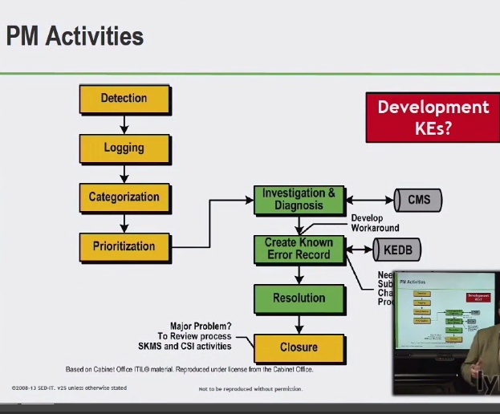

**MAJOR PROBLEM REVIEW**

* WHAT HAPPENED WHAT CAN BE DONE NEXT TIME
* FACILITATED BY PM (PROBLEM MANAGER
* AFTER CLOSURE

WHAT DOCUMENTATION NEEDS TO BE UPDATED – KNOWN ERROR DATABASE – USER GUIDES – HELP OPERATION TEAMS IN THE FUTURE

**DEVELOPMENT KE’S (DEVELOPMENT KNOWN ERRORS)**

* IF YOU HAVE PROPER APPROVALS
* DOCUMENT IN KEDB
* WORKAROUNDS FOR FUTURE RELEASE

**PROBLEM-MANAGEMENT INTERFACES**

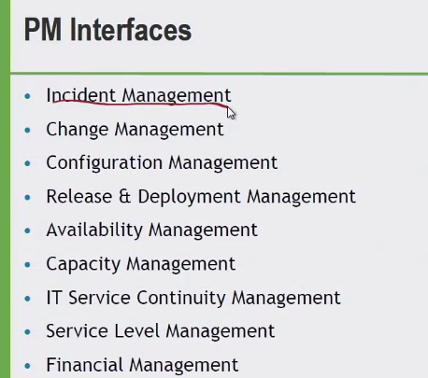

INCIDENT MANAGEMENT

* USE INCIDENT DATA TO IDENTIFY ROOT CAUSES

CHANGE MANAGEMENT

* IF WE HAVE A PROBLEM TICKET
* CHANGE REQUEST TO REMOVE PROBLEM FROM INFRASTRUCTURE

CONFIG. MANAGEMENT

* AS WE ROOT CAUSE ANALYSIS TOOLS/DB THAT HELPS US

RELEASE & DEPLOYMENT MAN.

* DEPLOY ANY CHANGES APPROVED AS RESULT FROM PROBLEM TICKET

CAPACITY MAN.

* HOW TO FIX ISSUES AROUND AVAILABILITY PERFORMANCE

IT SERVICE CONTINUITY MANAGEMENT

* IF TRIGGERED – MUST CREATE A PROBLEM TICKET TO REDUCE LIKELYHOOD OF PROBLEM IN THE FUTURE

SERVICE LEVEL MANAGEMENT

* PROBLEM TICKETS INVESTIGATING WHY WE ARE MISSING SERVICE LEVELS

FINANCIAL COST

* WHAT IS THE COST OF REDUCING/REMOVING PROBLEMS FROM ENVIRONMENT

**REQUEST FULFILLMENT**

**SERVICE DESK**

* **HANDLES INCIDENTS/*REQUESTS***
* **MOST ARE STANDARD CHANGES**

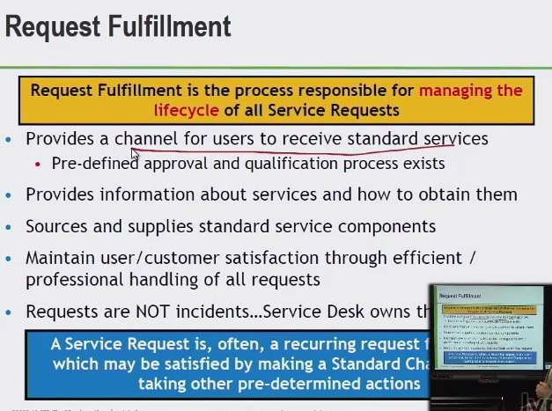

**^FOR USERS**

**^CHANGE OR BY**

**REQUEST FULLFILMENT**

* **PROCESS BEST SUITED FOR SELF-HELP TECHNOLOGY**
* **REQUESTS ASKED CAN BE AUTOMATED**

**ACCESS MANAGEMENT**

REQUEST FOR ACCESS – ADD/REMOVE FROM ACCESS

VERIFY WHO, WHAT ACCESS, ALLOWED TO DO, WHEN TO REMOVE ACCESS

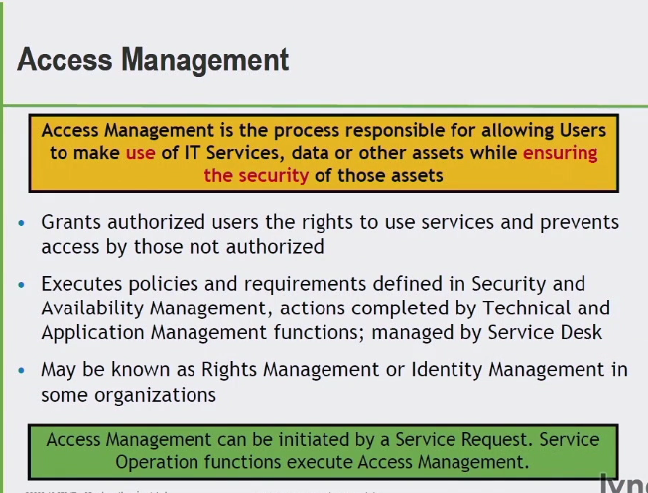

**ACCESS MAN. IS NOT AVAILABILITY/SECURITY**

**CONTINUAL SERVICE IMPROVEMENT: PHASE AND PROCESS OVERVIEW**

**7-STEP**

**SEVEN-STEP IMPROVEMENT PROCESS**

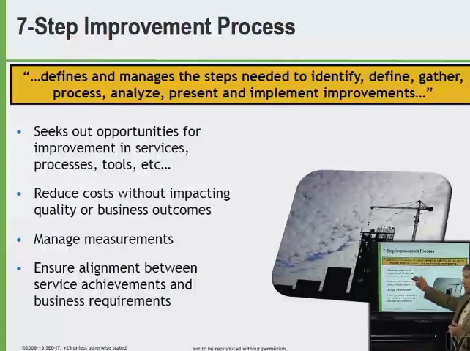

* ESSENTIALLY HOW TO COLLECT AND MANAGE DATA

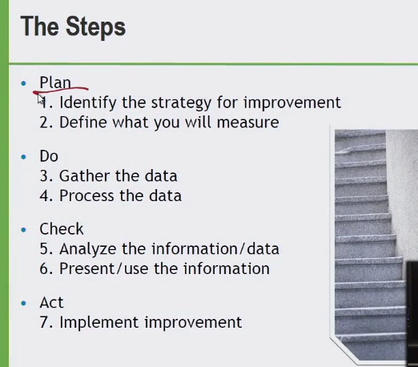

PLAN DO CHECK ACT – DEMING MODEL

GATHER THE DATA

* MULITPLE SOURCES BASED ON GOALS/OBJECTIVES
* PRIMARY/SECONDARY DATA

PROCESS THE DATA

* GET UNDERSTANDING
* KEY PERFORMANCE INDICATORS
* STANDARDIZE THE DATA
* MORE USUABLE/DATA

ANALYZE

* LOOK FOR TRENDS

PRESENT

* SHOW DATA

IMPLEMENT IMPROVEMENT

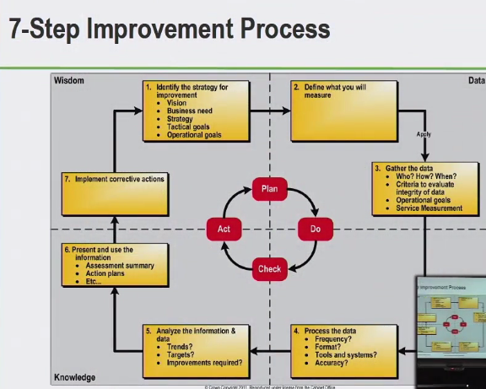

**SUMMARY: LIFE-CYCLE PROCESSES**

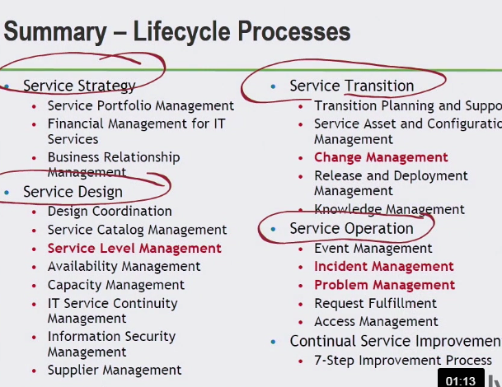

IF IT’S IN BLACK IS TO KNOW THE **PURPOSE, OBJECTIVES, AND SCOPE** OF THE PROCESS FOR THE ITIL FOUNDATIONS EXAM